Title of the abstract

Author Name¹, Author Name^{2*} (Include all of those who have made substantial contributions to this present work, even if the abstract was written by presenting author)

¹Affiliation, City, Postal Code, Country
²Affiliation, City, Postal Code, Country

*E-mail: Please write corresponding and/or presenting author’s official email(s).

Presenting Author’s Biography

Photograph of Presenting author
Please write a brief biography of presenting author. The text should not be more than 200 words long.

Graphical Abstract

Please make a brief schematic diagram as a ‘Graphical Abstract’. Insert those Graphics and Synopsis here and this can clearly illustrate your work.

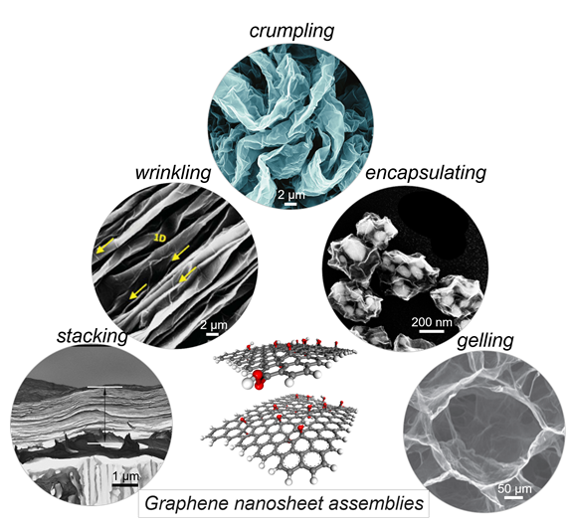

Abstract

All forms of research contribution at the conference must be accompanied by an abstract. In brief, the abstract should concisely describe the purpose of the research, indicate the experimental procedures used, summarize the key findings, and focus on the major conclusions. The abstract should be in one paragraph. Please complete your abstract here within 300-500 words.

Keywords: Keyword 1; keyword 2; keyword 3. (Include 3-5 Keywords)

Acknowledgements
Please acknowledge the funding authorities and other research supports.

References (Not more than 5, please follow the below reference style if any).
- M. Liu, C. J. Castilho, R. H. Hurt, Advanced Materials Letters, 2018, 9, 843.

