Title of the Abstract

Author Name¹, Author Name²* (Include all of those who have made substantial contributions to this present work, even if the abstract was written by presenting author)

¹Affiliation, City, Postal Code, Country
²Affiliation, City, Postal Code, Country

*Corresponding author: E-mail: Please write corresponding and/or presenting author’s official email(s).

GRAPHICAL ABSTRACT
Please make a brief schematic diagram as ‘Graphical Abstract’. Insert those Graphics and Synopsis here and this can clearly illustrate your work.

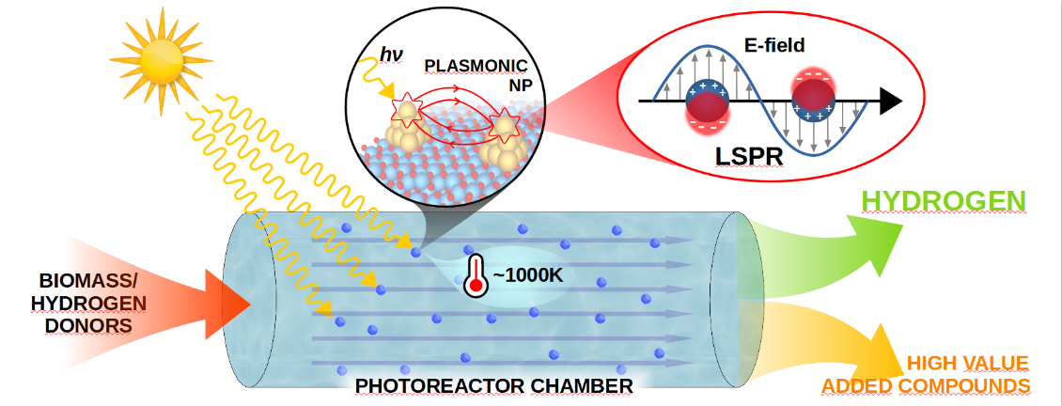

ABSTRACT

All forms of the research contribution at the conference must be accompanied by an abstract. In brief, the abstract should concisely describe the purpose of the research, indicate the experimental procedures used, summarize the key findings, and focus on the major conclusions. The abstract should be in one paragraph. Please complete your abstract here within 300-500 words.

KEYWORDS
Keyword 1; keyword 2; keyword 3. (Include 3-5 Keywords).

ACKNOWLEDGEMENTS
Please acknowledge the funding authorities and other research supports.
REFERENCES (Not more than 5, please follow the below reference style if any).
- K. Czelej, J. C. Colmenares, K. Jabłczyńska, K. Ćwieka, Ł. Werner, L. Gradoń, Catalysis Today, 2021, 380, 156
- K. Ćwieka, K. Czelej, J. C. Colmenares, K. Jabłczyńska, Ł. Werner, L. Gradoń, ChemCatChem, 2021, 13, 4458.
BIOGRAPHY OF THE PRESENTING AUTHOR

Photograph of Presenting author
Please write a brief biography of the presenting author. The text should not be more than 200 words long.

