Title of the abstract
Presenting Author¹, Co-author A², Co-author B³
¹Affiliation of presenting author including street, city, country and pin.
²Affiliation of co-author A including street, city, country and pin.
³Affiliation of co-author B including street, city, country and pin.

*Corresponding author: E-mail: xxxxxxxxxxxxxxxx

Graphical abstract

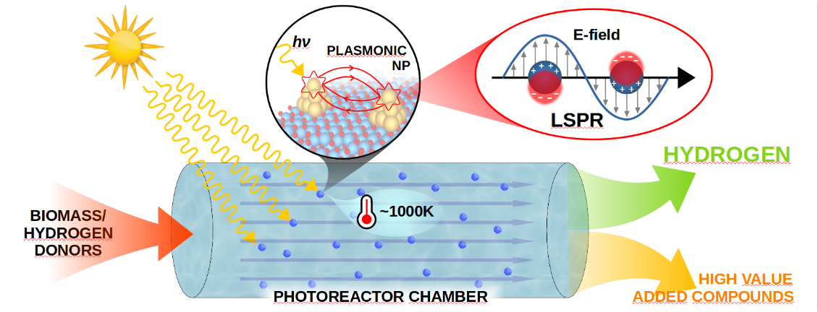
Please use a graphical abstract to define the work. 1-2 lines may be added here to define the graphical presentation.
Abstract
This place is for the abstract. The summary of the work, its context, novelty, experiments, results, discussion, and conclusion will all be briefly described in the abstract. The abstract should be no more than 300-350 words. (The in-text reference will be in brackets as [1-3], [4])
Keywords: keywords 1, keywords 2, keywords 3

Acknowledgments
Please acknowledge all the funding information and other related information in this section.
References
- Tiwari, A.; Advanced Materials Research and Innovation Priorities for Accomplishing the Sustainable Development Goals. Advanced Materials Letters, 2021, 12(6), 21061633.
- Mishra, A.; Shukla, Y.; Tiwari, A.; Advanced Materials and Convergence Technologies for Sustainable COVID-19 Healthcare Model. Advanced Materials Letters, 2021, 12(1), 21011589.
Biography of Presenting Author
Please include a short biography of the presenting author. The maximum word count should be in between 200 and 250.

